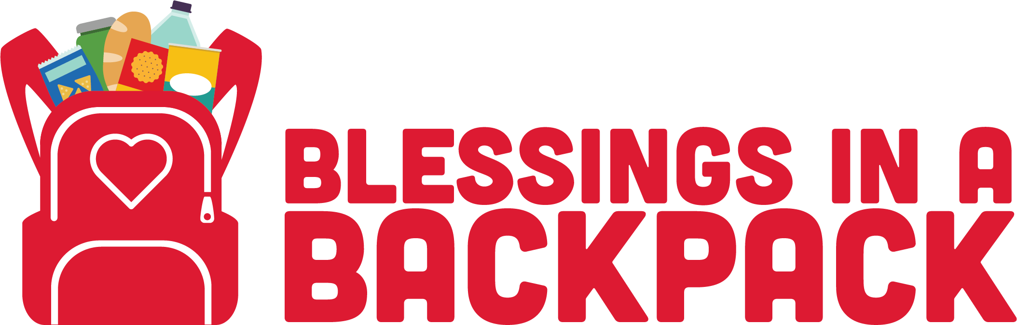

Information for Parents

THE FIRST BAG GOES HOME ON THURSDAY, SEPTEMBER 12!

- Please talk ahead of time with your child about receiving a bag of food. It’s important it’s not a surprise or that he/she thinks it was given to them by mistake and doesn’t bring it home.

- In order to get the best prices and stay within our budget, we have to shop for 4-6 weeks of food at a time. While we understand that your child likes variety, we use the inventory we have before we purchase a new order.

- Please clear out any unnecessary items from your child’s backpack before bag pickup day, so that they aren’t carrying extra weight with the addition of the food.

- At school on Thursdays, your child will be provided with a bag of food in the most discreet manner possible.

- It is ultimately your responsibility to check your child’s bag for any foods you do not wish them to consume.

- We are no longer providing any foods that contain peanuts. That being said, we cannot verify that the food was not from a facility that also processed peanuts.

- Special dietary needs bags will be coded with a pink piece of tape.

- If you wish to opt-out of the program at any time, please contact your child’s school secretary and let them know.

