LIMITED TAX PLEDGE
NOTICE

PLEASE TAKE NOTICE there will be a Regular meeting of the Board of Education of Grand Ledge Public Schools, Eaton, Clinton and Ionia Counties, Michigan.

At said meeting, the Board of Education will consider for approval its proposed State Aid Note (Limited Tax – General Obligation). The proposed State Aid Note (Limited Tax – General Obligation), if issued, will contain the limited tax full faith and credit pledge of Grand Ledge Public Schools, Eaton, Clinton and Ionia Counties, Michigan.

DATE OF MEETING: Monday, June 27, 2022

PLACE OF MEETING: Grand Ledge Administration Building
Board Room
220 Lamson Street
Grand Ledge, MI 48837

TIME OF MEETING: 6:00 p.m.

TELEPHONE NUMBER OF
PRINCIPAL OFFICE OF
BOARD OF EDUCATION: 517-925-5401

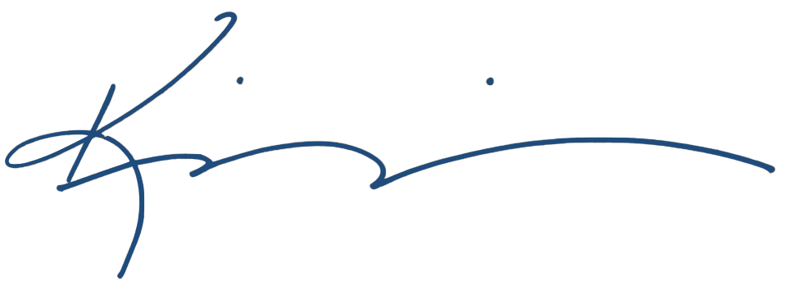
Board minutes are located at the principal office of the Board of Education located at 220 Lamson Street, Grand Ledge, MI 48837.

________________________________
Kim Manning, Administrative Assistant to the
Grand Ledge Public Schools
Board of Education

