March 9, 2018
3/12 Beef & Cheese Nachos or Cereal Fun Lunch
3/13 Chicken Nuggets w/Roll or
Goldfish Bread, Pizza Sauce & Cheese
3/14 Bosco Sticks & Dipping Sauce or
Sweet & Sour Chicken w/Rice
3/15 Berry Patch Smoothie, Cheese Stick & Crackers or
Cheese Quesadilla
3/16 Grilled Cheese Sandwich or Cheeseburger
Thank you for all those who donated so far to Relay for Life. Look for more fundraisers each Wednesday in March.

MESSAGE FROM MRS. KENNAUGH

It was another great week to be a Beagle Comet! Students have really taken to our Stop, Drop, and Read initiative going on here at school! And, it seems as though students are enjoying some reading at home as well--I have thoroughly enjoyed seeing the pictures of students reading on our PTO Facebook page. Keep them coming!

Thank you to all of you who attended Parent-Teacher conferences this week. We appreciate you partnering with us to help your child(ren) succeed.

Our staff appreciates our PTO volunteers and generous donors who donated time or items for our staff luncheon. Thank you!
We need your help with morning arrival! If your student is walking to school or being dropped off, it is important that they arrive after 8:25. We do not have coverage outside until then; our coverage begins inside at 8:30. Many students are arriving too early, which could be unsafe due to not being supervised. Please also take into consideration the cold or wet weather when dropping off early. It really is in your child’s best interest to arrive after 8:25. Thank you for your diligence with this!
DATES TO REMEMBER
Fri. Mar. 9 Afternoon Conferences 1-4 pm
Half Day for Students – Dismissed at Noon
Wed. Mar. 14 Beagle Literacy Night
Fri. Mar. 23 Science Fair 6-8 pm
Fri. Mar. 30 No Students – Good Friday
Apr. 2 – 6 No Students – Spring Break
Fri. Apr. 27 Family Fun Night / Silent Auction
Fri. May 25 Half Day for Students – Dismissed at Noon
Mon. May No School – Memorial Day
Tues. June 5 Last Day for Students – Dismissed at Noon

As always if you have any questions or would like to discuss any concerns, please call or email me.

MILEAGE CLUB
It's time to register for Mileage Club! The program will run from April 9-May 25, giving kids the chance to run/walk laps during their lunch recess. They can earn prizes, have fun, and be healthy! The program is free and students are under no obligation to participate. But they must be registered in order to earn prizes. Visit www.sparrowmilesclub.com and sign up your student today!
WACOUST
This is our 3rd annual Run for the Dream. The event was created to fund the building of the Dream Depot 2.0 playground at Wacousta Elementary School. The overwhelming support of the community has been appreciated.
Our dreams can take many shapes and this year we are proud to dedicate the funds toward the purchase of a wheelchair accessible van for one of our alumni students, Beth Koenigsknecht. Beth deals with a progressive neuromuscular disease. Her mother, Theresa, is a staff member at Wacousta and this will enable them to give their daughter more mobility and independence. Please consider supporting this worthwhile cause while enjoying the camaraderie of friends and neighbors of our community.
T-shirts are available to order until April 2. Please visit our "store" section to order yours now! Thank you for supporting this event! https://runsignup.com/Race/MI/Eagle/RunfortheDream

RELAY FOR LIFE FUNDRAISER EVENTS
Monday, March 12th – A&W Fundraiser – $5.99 Spaghetti Dinner -$2 from every meal purchased between 11 am and 8 pm will be donated to the American Cancer Society.
Wednesday, March 14 – Sucker Fundraiser
$1 Minimum Donation in Cafeteria
Wednesday, March 21 – Hat Day $1 Donation

ONLINE VOLUNTEER REGISTRATION
Persons interested in volunteering at any Grand Ledge school or chaperoning a field trip should log on to the Volunteer Registration Form located under the Parent / Student Resources Tab on the district’s website at www.glcomets.net. Once the requesting volunteer submits the form and shows identification at the school office, the district’s central office will complete a background check through the Michigan State Police. Following a successful background check, volunteers are placed on an approved list of volunteers and can volunteer in any of the Grand Ledge Public Schools building.

Receiving Text Messages/Alerts
As we continue to strive to improve communications, we want to let you know you can register to receive text messages from Grand Ledge Public Schools! This is not something the district automatically sets up, but if it is something you would like to take advantage of, it’s easy to register.
To sign up, simply text “YES” to 67587*. As long as your cell phone is associated as a contact number for a Grand Ledge Public Schools student, you will be registered. After you “Opt In,” you will receive communications from Grand Ledge Public Schools in a text format whenever the message sender includes a text version.
*Make sure you have SMS Messenging enabled on your device.

SPRING SPORTS
Coed Spring Soccer 1st - 5th Grade
​Practices are held once per week for an hour and games are on Saturday mornings, starting the week of April 9th.
Registration Fee: $45 (includes a team jersey)
Registration Deadline: March 11, 2018
For more information and to register please visit:
www.glathletics.com ~ Click on the More Tab to find the Community Rec Programs
For questions please contact - Jen Daly, Community Rec Coordinator (517) 925-5440 dalyj@glcomets.net

Recreation Girls Softball 1st - 4th Grade
Runs on Mondays & Wednesdays starting the week of May 21st
Registration Fee: $45 (includes a team jersey)
Registration Deadline: April 29, 2018
For more information and to register please visit:
www.glathletics.com ~ Click on the More Tab to find the Community Rec Programs
For questions please contact - Jen Daly, Community Rec Coordinator (517) 925-5440 dalyj@glcomets.net

​Jr. Comets Softball​
Registration for 9-14 year old players for the 2018 Summer Softball program is now open. Practices will begin after Spring Break and games start the last week of school. Please visit www.jrcometssoftball.com to register. Late registration 3/8-3/24 - $125 … registration closes 3/24). If you have questions, please contact David Sage at Djsage31@msn.com.

GL MIDDLE SCHOOL EQUESTRIAN TEAM
Grand Ledge Middle School Equestrian Team is seeking 5th graders thru 8th graders to join us representing Grand Ledge in the Michigan Interscholastic Horsemanship Association (MIHA) meet in Mason, MI.

All riders are required to have their own horse and tack.
Please join us for sign up on March 19th at 7 P.M. at Hayes Middle School Library

4th Annual Sewing For Their Senses
Many of our children struggle with managing their sensory systems throughout the school day, which can cause discomfort, frustration, meltdowns, and behavior issues. This can affect student learning (individual and peer), social interactions, and the child’s self-esteem.

Whether you are a talented sewer or someone who can cut fabric or hand stitch, please JOIN US! Bring your own sewing machines, cutting boards/mats, and scissors/rotary cutters to help sew adaptive equipment for our Grand Ledge Public Schools' students. This equipment can help them manage their sensory input and be more successful in the school setting.

WE CAN MAKE A DIFFERENCE!
WHO: School Staff, Support Staff, Family and Friends of Grand Ledge Public Schools
WHAT: Sewing adaptive equipment for our GLPS' students
WHEN: Saturday April 21, 2018 - 10 am - 2 pm
WHERE: Delta Center Elementary 305 South Canal Road Lansing, MI
Donations are welcome too! You can sign up to donate items listed below, or a food item at www.SignUpGenius.com/go/9040D45AFAA2FAB9-sewing3:
- Monetary donations to purchase weighted pellets
- Fabric -3yd pieces of broadcloth or denim for inner blanket
- Fabric -3yd pieces of fabric for the outer blanket
- Shipping/strapping tape
- Spool thread and bobbin thread (white or beige)
Donations may be dropped off in advance to the offices at Delta Center or Beagle Elementary Schools.
Questions: Contact Shari Burg burgs@glcomets.net or Gerri Guild gguild@eatonresa.org

GL DESTINATION IMAGINATION Congratulations to Grand Ledge’s four Destination Imagination teams for their incredible finishes at their March 4 tournament. All four teams are advancing to the April 14 state tournament at Michigan State University.
In the Engineering Challenge, our middle school level team, “The Spectacles,” earned first place and our elementary level team, “The Gods of Grand Ledge” took second place. The Spectacles are Rachel Carlson, Naomi Fitton, Memphis Kocher-Markiw, Samantha Noldy, Margaret Rodriguez and Hannah Zinn, all from Delta Center (if a team member is in 6th grade, the team competes at the middle school level). The Gods of Grand Ledge are Delta Center students Brenden Bouton, Rebecca Patrick, Ethan Rejoice, Nadhaan Rejoice, Nathan Ruswinckel and Max Wotruba.
During the Engineering Challenge, teams had to design and build a structure that can withstand impacts from dropped weights; tell a story about a sudden event with dramatic impact; and design and create a visible or audible depiction of the story’s sudden event.
The Scientific Challenge Team earned second place at the middle school level. Our “Grand Ledge Blazing Builders” are KATELYN ROBERTS from BEAGLE, Joe Oser and Tej Patel from Delta Center and Dennis Ledesma and Zach Zulewski from Willow Ridge. In their challenge, they explored scientific concepts used in amusement park attractions, designed and built an attraction that uses scientific concepts during its operation, created a story that features the attraction operating in an unlikely location and portrayed that location using sights and sounds.
Also placing second were the “Maze Maniacs” in the elementary level Technical Challenge. Team members are Colin Flynn, Julian Lamb, Gretchen Lauback, Isabella Perez, Nathan Schroeder and Kaiden Schulze of Delta Center. During their challenge, the team built a device to travel through a maze while telling the story of about a journey through the maze. They also had to design and build a prop that transforms in the maze and away to remove an object from the maze.
At a tournament, the team also received an Instant Challenge where the team members had to think on their feet and produce a solution in a period of just 5 to 8 minutes.
Destination Imagination (DI) is a STEM-based extracurricular activity that promotes creativity and teamwork. Each season starting in the fall, teams of three to seven students pick a challenge to tackle, work on it at weekly practices, try their hand at instant challenges and then showcase their teamwork and solutions at tournaments. Challenges are in the technical, scientific, fine arts, improvisational, structural and service learning categories. Next year’s challenges are available now. Visit Clever Comets – Grand Ledge on Facebook for more information about Grand Ledge’s program.

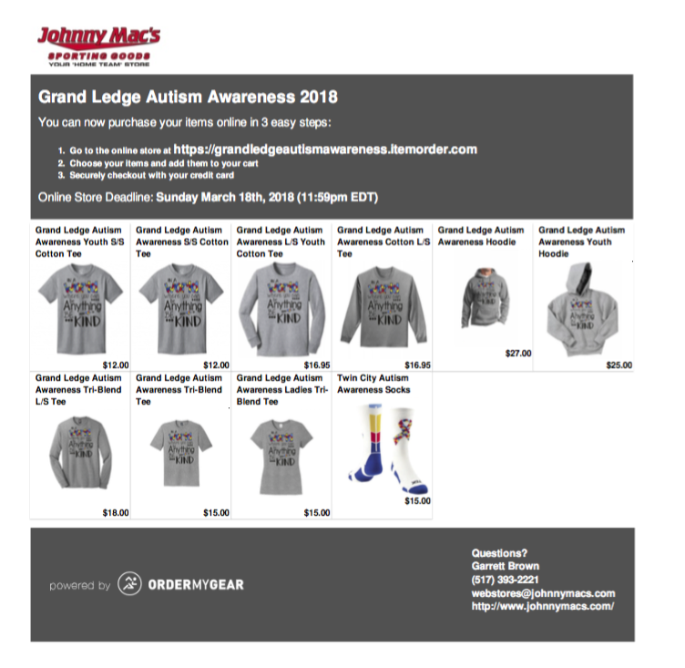

Your Grand Ledge Autism Awareness 2018 Web store is now live and will end March, 18th, 2018
To view go to https://grandledgeautismawareness.itemorder.com/sale?read_message=true

GRAND LEDGE AREA DISTRICT LIBRARY EVENTS

ST. PATRICK’S DAY PARADE
AND MEET & GREET WITH PETER RABBIT

Saturday, March 17 Peter Rabbit will march in the St. Patrick’s Day Parade, then head over to the library for stories from our own ‘Beatrix Potter’ (Cindy Langenberg).
Great photo op - bring a camera!

Meet and Greet with Peter Rabbit will take place at Grand Ledge Area District Library Main, 131 E. Jefferson St., Grand Ledge.

BABYSITTING WORKSHOP
Saturday, March 24 from 10 am – 4 pm
For teens 12-18 years old.

Learn emergency procedures, discipline techniques, diapering, age-appropriate activities, pediatric CPR, rescue breathing, the Heimlich maneuver, and basic first aid skills needed while babysitting. Upon workshop completion, students will receive a pediatric CPR card, a basic first aid card, and a babysitting course certificate.
Registration and class fee of $30 required. Participants will need to bring a sack. Payment can be made the day of the workshop and all checks should be made payable to C.P.R.C. Inc.
Workshop will take place at Grand Ledge Area District Library Main, 131 E. Jefferson St., Grand Ledge.

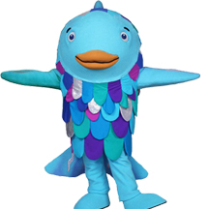
RAINBOW FISH STORYTIME AND MEET & GREET

Saturday, March 10 at 11 a.m. Rainbow Fish will join the Grand Ledge Area District Library’s Saturday Storytime. Great photo op - bring a camera!

SCIENCE NIGHT-- Friday, MARCH 23rd 6pm-8pm
We will have crafts/science experiments, an interactive student science fair (all students can participate) and prizes for best exhibits and experiments. Looking for volunteers to help assist with planning the event and helping during the event. Please contact via FB messenger: Tamara Lipsey for information to help: Facebook Name: Tamara Lipsey

SPRING 2018 FOOD DRIVE
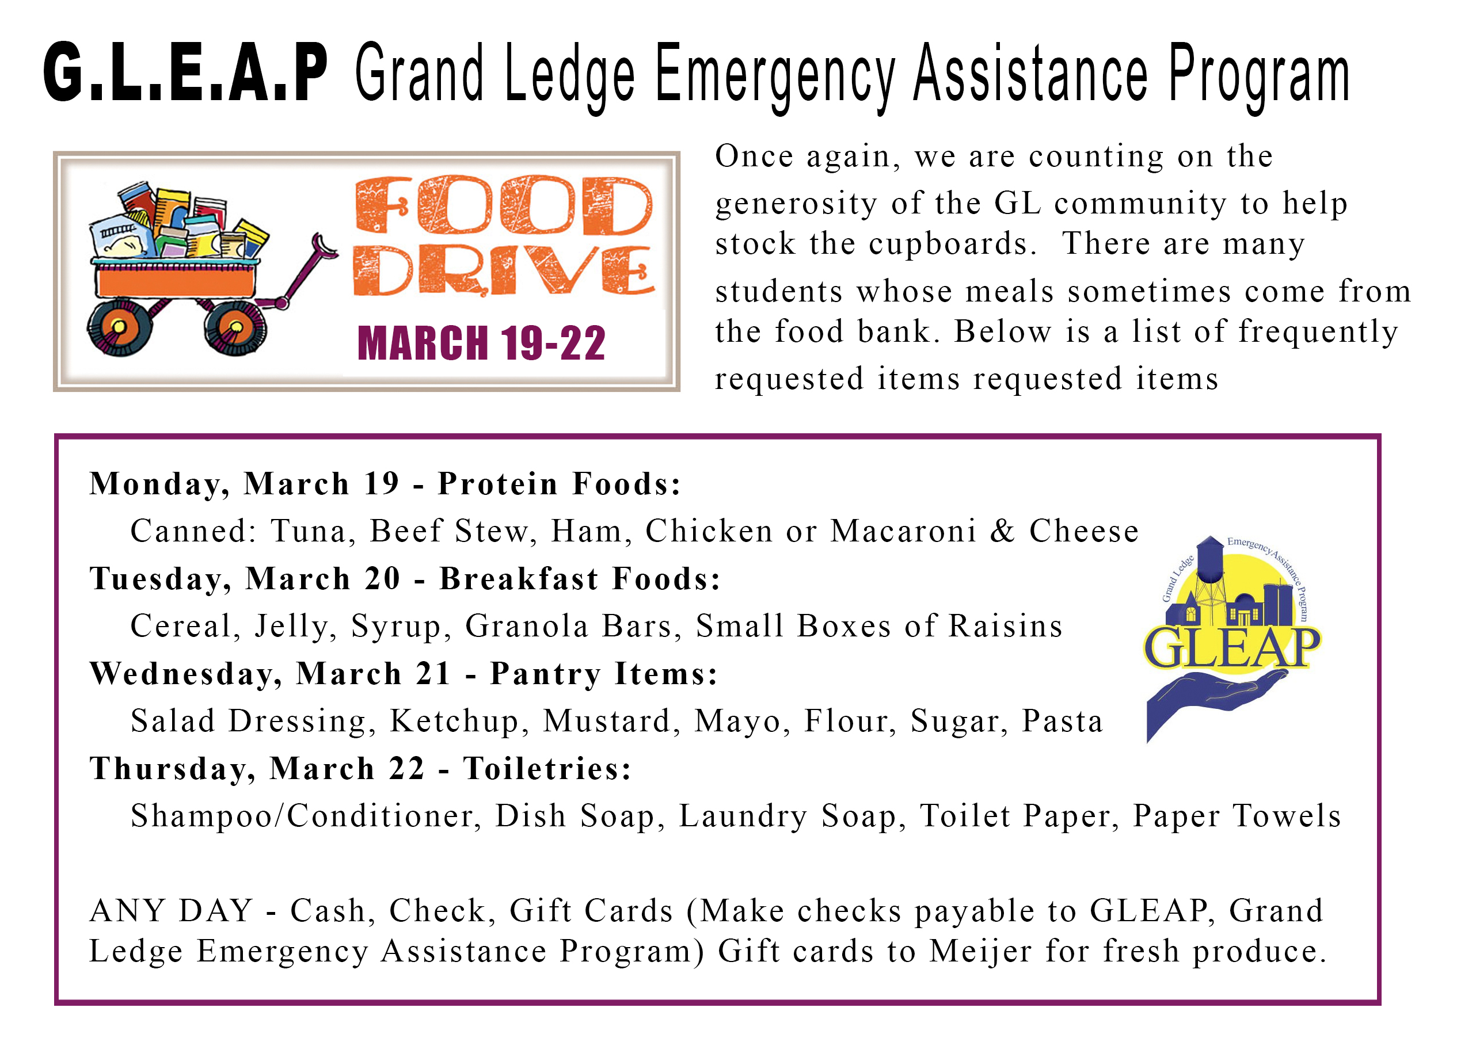
Thank you for supporting our Grand Ledge Community Food Bank!
For questions contact, Michelle D’Alessandro: mdalessandro@gleap.net Marlene Promer: mpromer@gleap.net
