DATES TO REMEMBER

May 26 All Library Books are Due Back
May 26 Half Day of School – Dismissal at 12:05 pm
May 29 No School – Memorial Day
June 8 6th Grade Recognition – 6:30 pm
June 9 Field Day
June 13 Pick up Medication
June 13 Last Day of School – Dismissal at 12:05 pm
** Summer Break **
August 21 First Day of School 2017-2018

The Principal’s Pen

VOLUME 21 – ISSUE 34 – May 26, 2017
We did it! M-Step is all finished! Once again I want to thank and recognize how hard and diligent the students worked on doing their best on this test. They are real troopers and we are all proud of them.

Here are a couple friendly reminders as we finish out this school year. First, please do not drop your student off before 8:40 unless they are enrolled in Adventure Club. I've noticed that some students are being dropped off before then and there isn't adult coverage until that time. Secondly, please be reminded that when you visit the school, parking in the loop is prohibited. You must park in a parking spot in our lot. This obstructs the access for emergency vehicles in the event an emergency takes place. Thank you for your cooperation in this matter.

Let's take a look at Mrs. Tennant's tenacious 4th graders:
Thanks to our wonderful PTA, all three sections of 4th grade had the opportunity to go to Woldumar Nature Center on Monday. We hiked through their prairie and forest while learning about the web of life. The children reviewed how producers (plants) use energy from sunlight with water and nutrients from the soil to produce their own food. This is the process called photosynthesis. The children then learned how primary consumers (herbivores and omnivores) get energy from eating the plants. Carnivores and omnivores who get energy by eating the primary consumers are called secondary consumers. They learned about what would happen to the balance of nature if any of the groups were eliminated from the web of life. This was a fantastic opportunity for the children to truly see the connection between science lessons and the environment.
James Gee, Principal

6th Grade Recognition

All 6th grade students and their families are invited to attend our 6th Grade Recognition scheduled for Thursday, June 8, at 6:30 PM. It will be a celebration culminating their years at Willow Ridge. Students will have a music performance and they will all walk in front of their peers to accept their certificates honoring the end of 6th grade.

Field Day 2017

This year’s Field Day is planned for Friday, June 9. The morning session (9:15) is for 4th, 5th and 6th graders. The afternoon session (1:15) will be for 1st, 2nd and 3rd graders. We need many volunteers to help run the events. Please call the office to sign up for morning, afternoon or both!!

Medication Pick Up
Your child’s medication(s) must be picked up at school on or before June 13. If the medication is not picked up by this date, it will be properly disposed of according to district policy/guidelines.

Student Council News

We had our ribbon cutting ceremony for the opening of our New GaGa Ball Pit on Monday. The kids are really enjoying playing GaGa Ball. A lot of adults, myself included, didn't know what GaGa Ball was until recently. Our GaGa Ball Pit is 22 feet in diameter and is made of a very durable Poly Vinyl material. Players use an ordinary playground ball. The ball is tossed in the air, and after bouncing 3 times, players rush up to hit or roll ball. The object is to get other players out by hitting them with the ball at the knees or below. The walls may be used to hit players from behind. Students can gain more coordination by playing this fast paced game. Student Council officers have been supervising play during recesses.
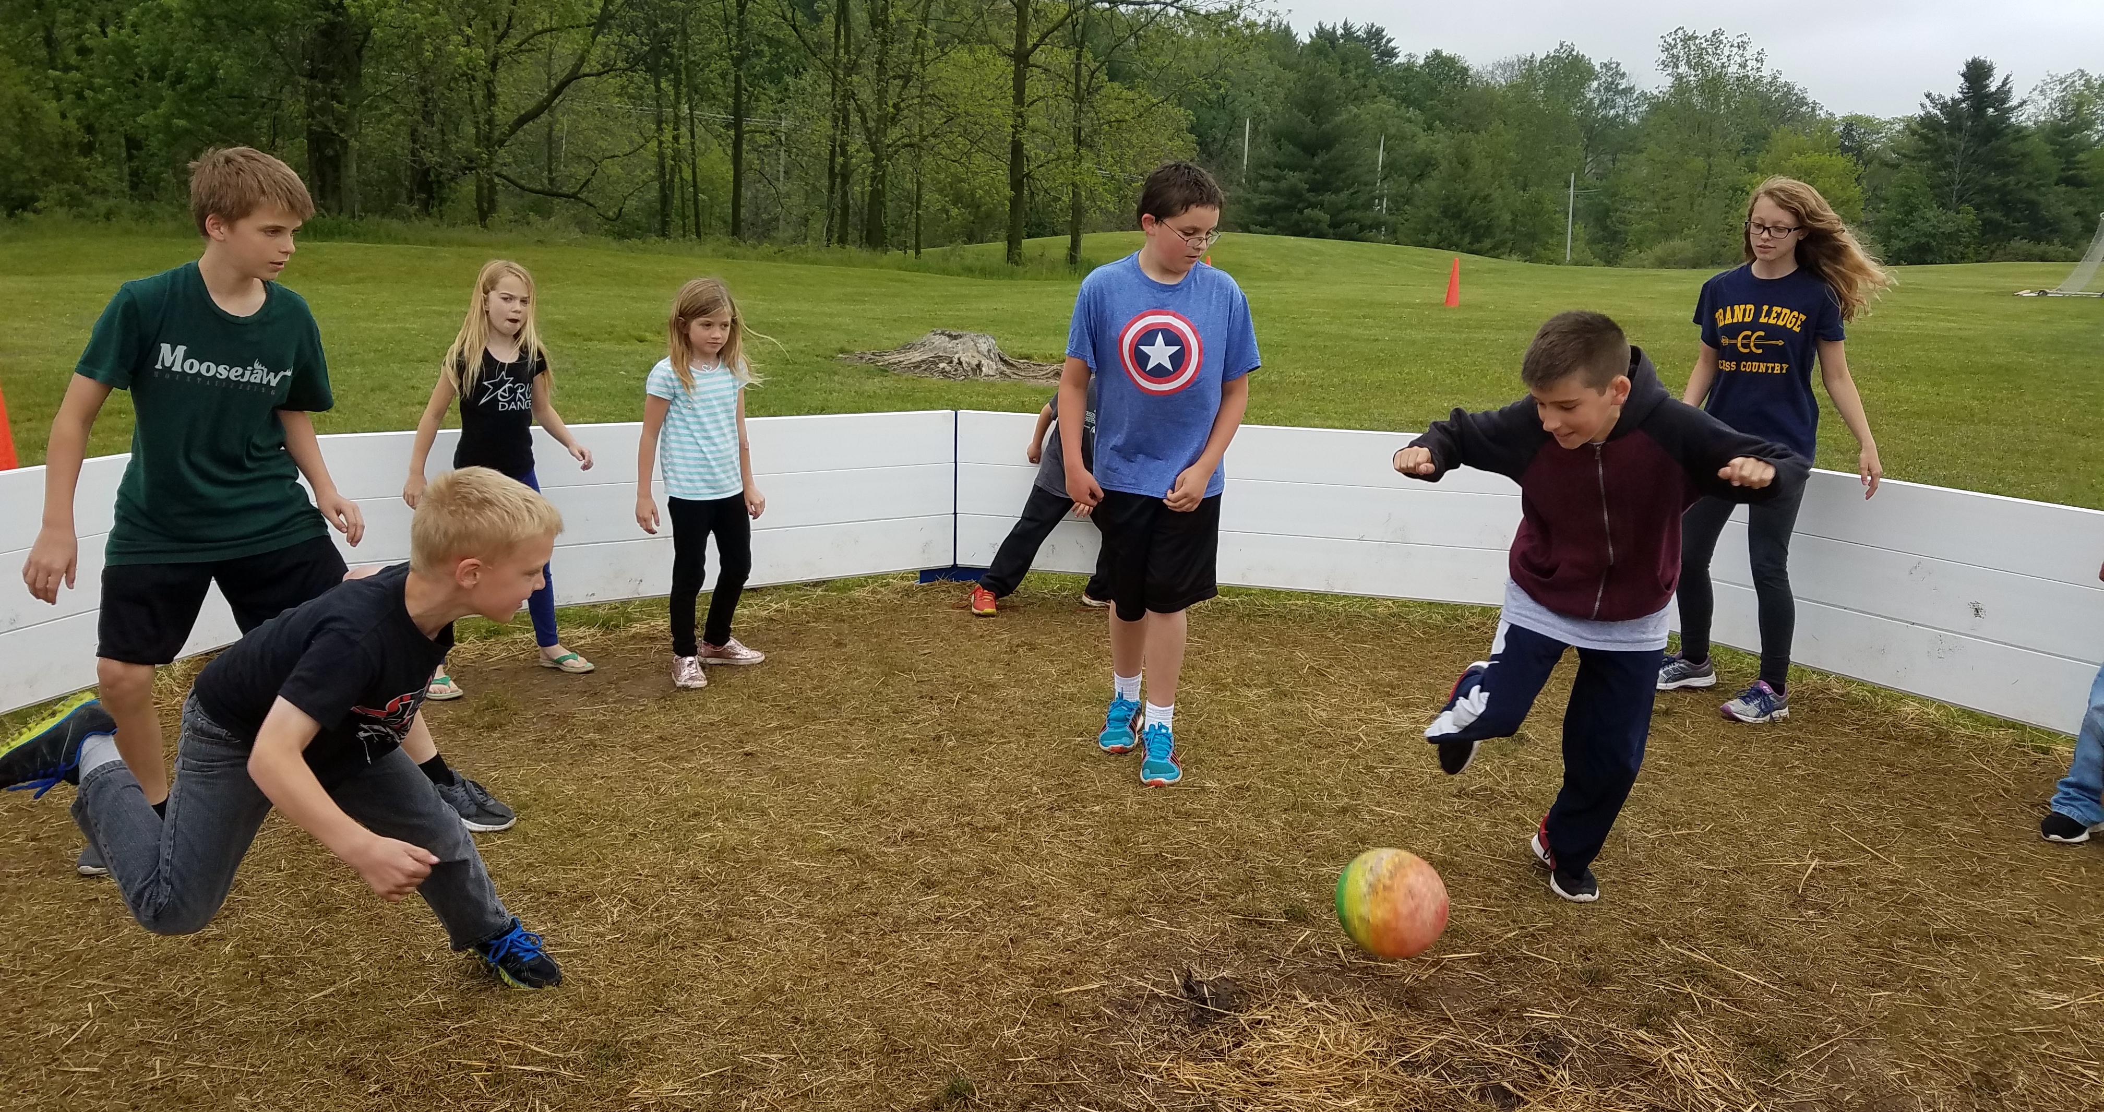
Spring 2017 Cross Country – We had 32 runners from Willow Ridge run 1.4 miles at Beagle last week. Willow Ridge had 5 runners from a field of 120 runners total come in the top 10.

Pictured: Alex Schafer – 8th place, Ashley Richburg – 8th place, Kayla Higbee – 7th place, Anya Heany – 10th place, and Colin Ertman – 9th place. Great job!!!
Upcoming Field Trips

5/31 – 3rd grade to Michigan Historical Museum
6/1 – 2nd grade to Downtown Grand Ledge
6/6 – 1st grade to Potter Park Zoo
6/7 – 6th grade to Island Lake State Recreation Area
6/9 – 6th graders to Hayes Middle School
6/12 – 5th grade to Greenfield Village

New Food Service Policy

Our Food Service Department is implementing a new policy next school year. Beginning in August 2017, elementary students may charge up to three lunch meals. If payment is not received after the third day, the student will be given an alternate meal (2 cheese sticks, graham crackers, fruit, and milk) instead of our hot lunch choices. Lunch accounts will be charged a reduced rate for that alternate meal. I encourage you to go to sendmoneytoschool.com to set up low balance email reminders. I have found them to be very helpful! If you have questions, you may contact Food Service at 517-925-5733.

First day of school
for 2017-2018
is August 21!!

Online Volunteer Registration

Grand Ledge Public Schools remains committed to ensuring the safety of its students. Persons interested in volunteering at any of our schools (including chaperoning a field trip, should log on to the Volunteer Registration Form located under the Parent / Student Resources Tab on the district’s website at glcomets.net. Once the requesting volunteer submits the form and shows identification at the school office, the district’s central office will complete a background check through the Michigan State Police. Following a successful background check, volunteers are placed on an approved list of volunteers and can volunteer in any of the Grand Ledge Public Schools buildings or chaperone a field trip.
Neff Kindergarten Registration Information

Welcome to Grand Ledge Public Schools! We are
looking forward to meeting you and your family! If
you need any assistance with this process, please call our Roundup hotline at 925-5725 and leave us a
message.

Your child must be 5 years old on or before December 1, 2017 to be eligible to enroll for the
2017 - 2018 school year. If they are 5 years old between September 1 and December 1, 2017
you will need to sign a waiver. The waiver is included in the enrollment packet.

To enroll your child please visit the Grand Ledge website at www.glcomets.net and click on the
Kindergarten Registration link. This will direct you to the registration page. After completing the
registration information you will be asked to choose a date/time for dropping off your documents at our Central Office, 220 Lamson St, Grand Ledge MI 48837.

Items to Bring:
❖Birth Certificate (Original, State Certified)
❖Immunization Records (Current)
❖Proof of Residency

It is important to note that it is MANDATORY to bring your child's original birth certificate, current
immunization record and proof(s) of residency to your scheduled appointment. You are responsible for filling out all the necessary kindergarten paper work prior to Roundup.

The Kindergarten Roundup for this year will be held in May. The dates to choose from will be available at our central office when you drop off your child’s documents. There will be 2 sessions to choose from each evening. The first session each evening starts at 4:30 pm and the second starts at 6:00 pm.

Enrollment Info for Current Students

If your child is already enrolled in a Grand Ledge school they will be automatically enrolled with GL Schools for the next year. If you are an out of district Schools of Choice family and would like to continue in Grand Ledge schools for the 2017-2018 school year, please email D’Anne Golub at golubd@glcomets.net before June 1, 2017.

If you have moved out of district, Grand Ledge Public Schools is open for unlimited Schools of Choice for the 2017-2018 school year for Kindergarten through 9th grades. You must complete the Schools of Choice Application at www.glcomets.net before August 25, 2017 at 4:00 p.m. if you want your student(s) to continue at Grand Ledge Public Schools. If you have a student 10-12 grade, please complete the Tuition Application and follow the directions for that. If you have any questions, please call 517 925-5447.

Bus Route #17

The Transportation Department has advised us that Route #17 is completely full. We will not be able to write any bus notes for additional students to ride Route #17.

Absences and Leaving Early

- Please contact the office by 3:30 pm if you are picking up your child early. This allows adequate time to notify your child and their teacher of the change. Please come to the office, check in the with the secretary, and wait for your child to come down to the office.
- Students should not be dropped off before 8:40 am. Proper supervision is not in place before that time. All students who don’t take the bus home should be picked up at 4:00 when school dismisses. We have a lot of students waiting for rides long after the bell rings. We understand that things happen, traffic congestion, etc. Please give us a courtesy call if you are running behind.
- If your child is going to be absent, please call the office at 517-925-5775 or the 24-hour attendance line at 517-925-5812. If your child is going to be late (and needs to order a lunch), please call in by 9:10 am. You may leave the information on the 24-hour attendance line. Please leave the name of your child, their teacher’s name and the reason for their absence on the message. If your child has a fever, is vomiting or having diarrhea, please note that in order to return to school they must be free of their symptoms for 24 hours. Thank you!

2017-2018 School Year

We are starting to plan for next year. If you know your student(s) will not be attending Willow Ridge next year, please contact our office at 925-5775. Additionally, if you know of possible new students to the area, please encourage them to give us a call.

